OSUWMC Staff should use SharePoint MyTools to access additional content.
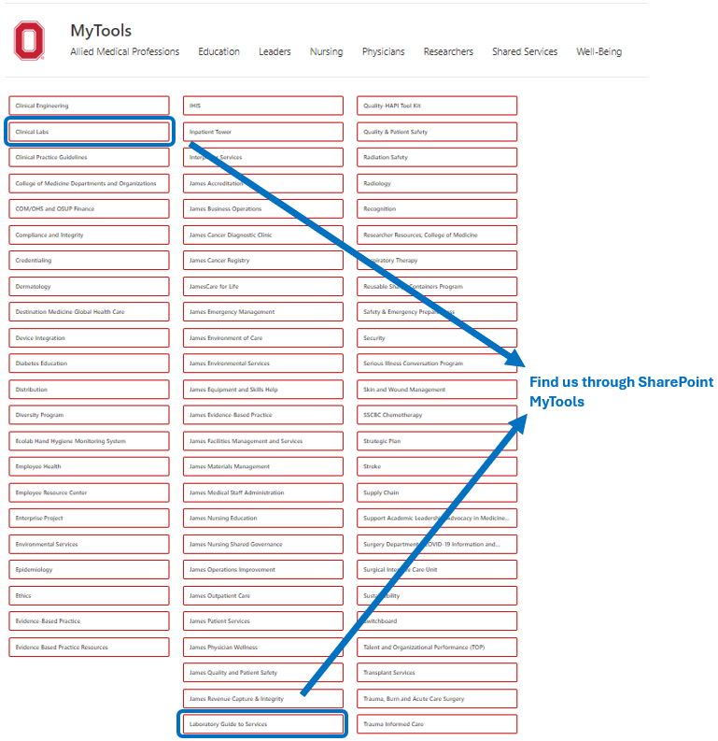

Click on Resources → Depts. / Sites

Clinical Labs
-OR-
Laboratory Guide to Services

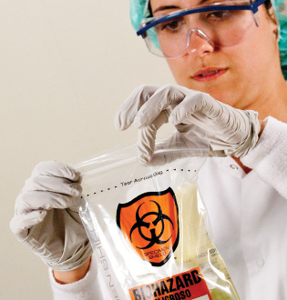

Outside Clients can
visit us here:

clinicallabs.osumc.edu

Welcome to the

Clinical Laboratory Guide to Services

Available on SharePoint MyTools

Laboratory Contacts

Customer Service
614-293-8375
(Inpatients/Outpatients)

Pathology Results
614-293-5905

James Oncology Lab
614-293-8616

Outreach Customer Service
614-293-9281

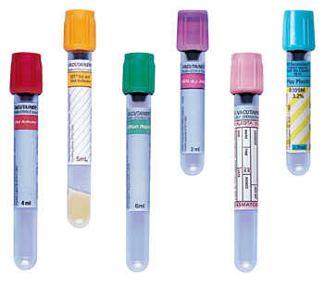

1-800-227-5062


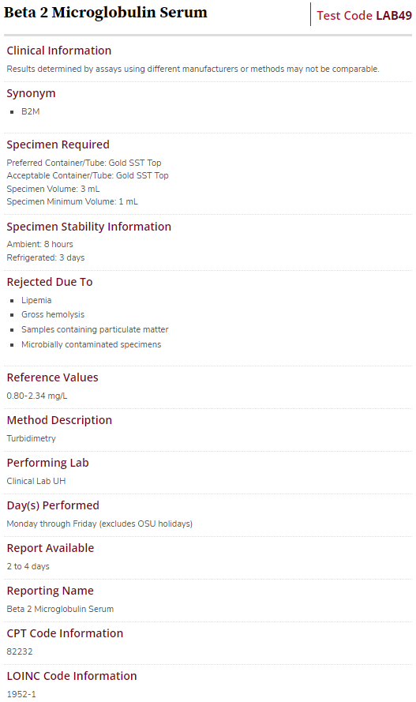
Point of Care Testing
Web page has all related documents grouped by instrument

- Package Inserts
- Policies and Procedures
- Competency Forms
- Quick Guides
- Temperature and Maintenance Logs
- Operators Manual
- Safety Data Sheets (SDS)

Test Catalog:
Includes testing information for send out testing to referral laboratories

Included testing information:
- Clinical Information
- Specimen Types & Collection Details
- Reference Ranges
- Detailed Methodology
- Expected Turnaround Time
- CPT and LOINC Codes
clinicallabs.osumc.edu
Clinical Laboratory Guide to Services
Your portal to laboratory information

Specimen Requirements: Defines acceptable specimen type(s) and any other specimen requirements.

Reference Ranges: Describes reference intervals. Includes intervals based on age and sex as appropriate.

Availability / TAT: Indicates location of the laboratory that performs the test and outlines the days/times the test is performed. Also defines expected turnaround time from specimen receipt until release of test result.

Billing Information:
Lists all CPT and LOINC codes, including codes for reflex testing when applicable.

Laboratory Policies and Procedures
- Point of Care Testing Documents
- IHIS Policies and Tip Sheets
- General Policies and Procedures

Forms and Requisitions
- Requisitions are purchased through the contracted vendor RR Donnelley

Transfusion Services
- Blood Product Guidelines
- Guides for Specimen Labeling
- Blood Utilization

Department of Pathology
- Academic Programs
- Pathology Divisions
- Faculty
- Services
  - Cytogenetics Test Menu
  - Molecular Pathology Test Menu

Laboratory Test Catalog
- Links to Additional Test Menus
- Specimen Collection Policies
- Customer Service and Outreach
- Additional Resources
  - Common Reference Ranges
  - Critical Values List
  - Test Change Notifications
- Links to Additional Pages
  - Compliance and Accreditation

