POLICY
  - Critical tests, critical results, and courtesy calls on inpatients, outpatients, and outreach patients will be communicated to a clinical professional responsible for the patient’s care in a consistent and timely manner.

    - Critical Tests:
      - Critical tests are those tests which will always require rapid communication of the results, even if normal.
      - Critical tests will be communicated to a clinical professional responsible for the patient’s care, regardless of the test result, within specified time interval from order/collection to result. Such notification shall be documented.
      - Critical test specimens should be delivered to the Clinical Laboratories within 10 minutes of order/collection.
      - True collection times should be documented on the specimen/lab label.
      - Critical Tests: Rapid intact parathyroid hormone (RPTH) and single block frozen sections

    - Critical Results / Critical Values
      - Critical results, also known as “critical values,” are test results that fall significantly outside the normal range and may represent life-threatening values, even if from routine tests.
      - Critical results will be communicated to a clinical professional responsible for the patient’s care within 20 minutes of completion of the test, and such notification documented as a component of the test results report.
        - Note: Microbiology critical results must be called to the ED charge nurse for discharged ED patients.
      - LIS Comments are: Critical Results were verbally communicated and read back.

    - Critical Results in Point of Care Testing (Glucose)
      - The PCA, (unlicensed assistant personnel) must notify the RN and document first and last name in the medical record.
      - See Point of Care Glucose Policy for current directions

    - Courtesy telephone notification
      - Courtesy telephone notification for other specified tests/results will be communicated to a clinical professional responsible for the patient’s care and such notification documented as a component of the test results report.

    - Personal Health Information (PHI) including name and medical record cannot be included when paging a critical value. Use appropriate language such as: Please call the OSUWMC Lab at (614)293.xxxx for a critical result.

  - Manual and automated results are verified before final acceptance and reported by the computer.
    - Laboratories should have a system in place for verification of manual entries – can be performed by same tech or another technologist.
      - Laboratories can utilize the “Final Verify” step in Beaker, manual log double checking, patient printout verification, or other processes that are applicable to the testing.
    - Staff members should review all results that are not auto-verified in the computer – evaluating flags, reference ranges, and improbable results, as applicable.

PURPOSE OF DOCUMENT
  - This policy is to provide a mechanism for pathology and laboratory staff to communicate and document rapid communication of laboratory test results.

SCOPE OF DOCUMENT
  - This document applies to all areas within the Clinical Laboratories, as well as medical center collection sites.

RESPONSIBILITY
  - The Medical Directors of the Clinical Laboratories are responsible for establishing the Rapid Communication of Laboratory Results policy. Laboratory Compliance is responsible for maintaining the policy and ensuring at least biennial review.
  - Laboratory Compliance is responsible to providing the policy to clinical staff, available on the laboratory website.

Critical tests – process
  - Critical tests are those tests which will always require rapid communication of the results, even if normal.
  - Critical test specimens should be delivered to the Clinical Laboratories within 10 minutes of order/collection.
  - Critical tests will be communicated to a clinical professional responsible for the patient’s care, regardless of the test result, within specified time interval from order/collection to reporting (see below). Such notification will be documented.

Critical tests
Tests | collection | TAT (collection to notification)
RPTH | If collected in OR on the Main Campus; Call 293-3443 to notify lab staff and deliver directly to Special Functions Laboratory.  If collected in OR at The James Outpatient Care; Call 614-814-9039 to notify lab staff and deliver directly to The James Outpatient Care Laboratory.  If collected in OR at University Hospital East; Call 614-366-9922 to notify lab staff and deliver directly to East Rapid Response Laboratory. | 40 minutes (30 minutes receive to notification)
Frozen sections | Specimen is delivered to surgical pathology gross room. The results are communicated via telephone by the pathologist signing out the frozen section to an attending or resident physician in the operating room. | 40 minutes (30 minutes receive to notification)

Critical Results – PROCESS - Overview
  - When rapid communication of laboratory results is required, testing and client services personnel of the Clinical Laboratories notify a clinical professional (e.g., RN, LPN, physician, nurse practitioner, respiratory therapist, pharmD, physician assistants, etc) responsible for the patient's care. Other titles can be approved by the Laboratory Medical Director.

  - Determine the location from which the patient specimen was sent.

  - Call the area that submitted the specimen and tell them you have a laboratory result to report. Ask for a clinical professional taking care of the patient.

  - The ordering physician is ultimately responsible for acting on the critical value.

  - Document communication trail, through problem log, or other means of handoff communication.

  - Report ALL of the following elements:
    - your first and last name and laboratory from which you are calling
    - patient's name
    - patient’s MRN
    - patient phone number: for all non-inpatients or non-ED patients’ notifications
      - Note: Outpatient / Outreach Patients - MANDATORY: For any notification for non-ED outpatients or outreach patients, obtain the patient's phone number and provide to the clinical professional along with the results. Look in IHIS by patient name for phone number.
    - name of attending physician
    - collect date and time of specimen
    - test name(s)
    - test results
    - units of measure, for NICU patients only

Readback (CAP Standard):

Request read-back verification of the test result(s). This must include patient name, MRN, test name(s), test result(s) and units of measure for NICU patients.

Documentation Elements:

Document telephone communications / notifications in the results report in the applicable LIS. Include all of the following elements:
    - First and last name and title (e.g., Dr. or RN) of person notified / who verified/read-back the results.
      - Medical center ID (XXX01) can also be used to identify an employee. This is a unique employee ID that will convert to first and last name in EPIC.
    - Date of communication
    - Time of communication
    - Responsible individual communicating the result
    - Test Results

Documentation Steps in Beaker:
    - Click on Comm Log located in the upper left corner of the screen. The Comm Log opens as a side bar.
    - Click Other.
    - Enter name in the Search by Name field and press Enter.
    - Click on appropriate name. Notice how it populates in the Contact field.
    - Click Accept.
    - Click the Verify to review your result.

IVQ or other Questionable Specimens:
    - Call the caregiver and explain your concerns.
    - You can give a ballpark figure for Critical Values- “This result is < than X and I am concerned that there is a sample problem.”
    - Ask the person if they are expecting this type of a result and if they need it released. If not expected ask for a re-collection.
    - Let them know that you can post results if they must have them, but they will be released with their name documented as requesting the value be filed.
    - Do not delay posting any result if the RN/Physician thinks it should be released.
    - Call the Path who is on call for any situation that cannot be resolved or that may need more discussion with the physician.

Critical Results – Personnel

Inpatients / Emergency Department
    - Call the area that submitted the specimen and tell them you have a laboratory result to report. Ask for a clinical professional taking (usually the nurse) care of the patient.
    - If the nurse involved with direct patient care cannot be reached or cannot take the result, request to speak to the floor charge nurse.
    - If the charge nurse is not available or cannot take the results, page the ordering physician.
    - If the inpatient unit or ED is not able to take the critical result because the patient has been discharged, contact the ordering physician’s office.
      - To locate the office number, use the directory on MyTools, hospital operator 3-8000, URL account / client database listing, or Google/web search.

    - If unable to contact the ordering physician – follow the directions described below.

Critical Results – Outpatient – Routine Hours
    - During routine clinic / patient care hours – call the physician office that submitted the specimen and tell them you have a laboratory result to report. Ask for a clinical professional taking care of the patient.
    - Follow process described above to communicate the critical result.
      - To locate the office number, use the directory on MyTools, hospital operator 3-8000, URL account / client database listing, or Google/web search.
    - To correctly direct your call, the following smart phrase is used by Primary Care schedulers within the Patient Contact Center:
Are you calling to report a critical value? Yes-variable/no:18474}
- If Yes, Warm transfer to Triage RN

Are you calling to have a lab redrawn and need new orders placed?
Yes-variable/no:18474}
- If Yes, route to home clinic RN pool

Date of the lab draw. ***
Name of Caller: ***
Lab Name: ***
Name of RN call was transferred to: ***

Critical results – Outpatient - After Hours Notifications
    - If the notification must be made after the care area closes, contact the on-call physician, or other person as designated by the client, directly UNLESS the patient care area has submitted a written request for notification to be made only during business hours.

    - To locate the office number, use the directory on MyTools, hospital operator 3-8000, URL account / client database listing, or Google/web search.

    - The result remains on the outstanding list until communication is made. You have the ability to document multiple attempts until it is communication. You do not have to modify the results; you are just adding communications via the Comm log.

      - Add comments to Lab Level Comments
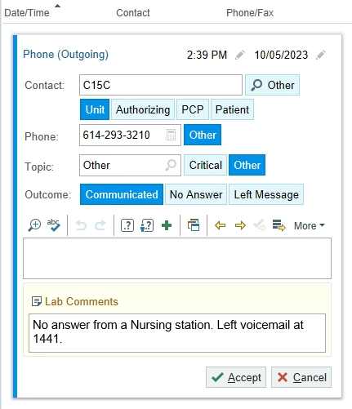

Critical Results – Exemptions / Special circumstances

Physician / Location Exceptions
    - Check the Critical Value Exception list (ADMIN-GRT-13) to know when if a physician or a location has deferred critical value calls and if there are any further special circumstances.

    - For URL Clients, the URL database has detailed information about “call to” numbers that can be helpful.

    - For approved exemptions / special circumstances: Laboratory Compliance will send an email to the UH/James Laboratory Medical Director with specific information about the request and will save the documented approval.

      - If receiving a request for a new exemption, collect as much information as possible (including contact information for the caller and or physician). Email Laboratory Compliance with the request.

      - Documentation is saved here: \\osumc.edu\dfs\Shared\Pathology\APCP_Testing Info\Critical Result Exceptions

Pathologist Determination
    - If “after business hours” communications are not successful and the pathologist determined an immediate notification is not required, follow the Morning Notification Process described below.

Semi-Urgent Results for Mayo
    - Treat as critical results and call and document using comm log.
    - Secure Chat and Inbasket messaging must never be used for critical results or semi-urgent results (Mayo)
https://www.mayocliniclabs.com/order-tests/critical-values-and-results

Critical Results, Previously Called
    - Review the previous result for the analyte and determine if it was a critical result and the collect date for that specimen.
    - If there was no previous result for the analyte, call the result within 10 minutes of test completion and document as indicated above.
    - If the previous result for the analyte was not a critical result, call the result within 10 minutes of test completion document as indicated above.
    - If the previous result was not from the current admission, call the result within 10 minutes of test completion document as indicated above.
    - If the previous result was called or “CVPC” (critical value, previously called) code was appended to that result, and the specimen was collected during the current admission, append code “CVPC” to the current result.
      - This code can be utilized on WBC (C14, C16, C15, C20, C21), and Troponin.

Pre-Transplant Clinic
    - For after hours’ notification for the Pre-Transplant Clinic (PRET, PRETX): WebXchange page the Pre-transplant On-call Coordinator at pager (614)3464051.
    - From MyTools WebXchange Pager ID
      - Enter Pager ID: 4051
      - Enter the Alpha Msg: “Please call the OSUMC Lab at (614)293.xxxx for a critical result”
      - NOTE: Be sure to use a phone number which can be accessed from the outside.
    - There will be times that the coordinator staff will be on the phone dealing with organ procurement/processing, so there might be some delays with call backs.
    - Enter the time the coordinator was paged and the time that they returned the call as part of the documentation of the call.

Direct to Consumer Testing
    - Outreach – OSU Lab Test DTC (U18115 through U18122):
    - Notify the Medical Director of the Clinical Laboratories, pager 6370.
    - Provide the Accession Number, ID number, collect date and time, test name(s), and test result(s).
    - The Medical Director of the Clinical Laboratories will work with the appropriate personnel at URL to determine the identity of the DTC consumer and contact the consumer directly so that such results are communicated to them in a timely manner.

Specimens Referred from Another Laboratory:

When rapid communication of laboratory results is required for specimens referred from an outside, non-OSUWMC laboratory, a laboratory professional from that laboratory is notified and the communication documented per described above.

Anonymous Specimens:

critical results, critical tests, or courtesy call notifications for anonymous specimens will be made only during business hours.

    - For specimens identified as research subjects: contact information for critical results notification is pre-printed on the customized, study-specific requisition form.

Research Specimens
    - For critical values, following the directions in the URL database or on the research set up paperwork. All research studies should list directions for critical values when establishing research accounts with Research Billing and LIS.

Special Circumstances
    - If a specimen runs extra testing due to extenuating circumstances (for example: errors with receiving, down times, IT limitations, instrument limitations) – extra results do not need follow up action. The laboratory is ONLY responsible for testing ordered by an authorized provider. If technologist has clinical concerns about a value that will not be ordered/resulted – please consult a division/laboratory medical director.

Morning Notification Process
    - When resulting/reviewing the testing; Do not final verify the result- this result must stay on the Outstanding List.
    - Print a Specimen Preview Report make a note on it that it is a “XXX Location - to be called next AM, then write the date, time, and your initials on the report”
    - If necessary, attach an instrument print out to the report.
    - Send an email to all staff to alert staff that this result will be pending and include where the patient report is located so that the day shift tech can find it easily.
    - The next day, this test value (which should still be on the outstanding list) needs to be called during regular business hours but as early as possible.
    - Any pending critical value should be part of the shift-to-shift hand off and must be communicated to any incoming tech.
    - The next day- the tech(s) on the bench where the result is pending is assigned as being responsible for calling this result.
    - If there are multiple critical values (spanning more than one bench) please communicate with the tech on the alternate bench. Best practice would be to include this information in the email sent to the lab.
    - Call and document the proper information in the Comm-Log then final verify the result.

Print Directions
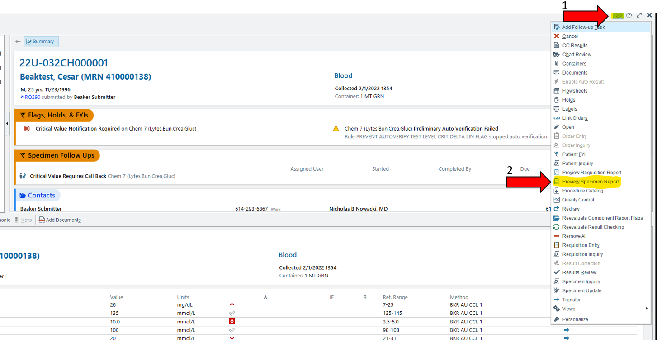

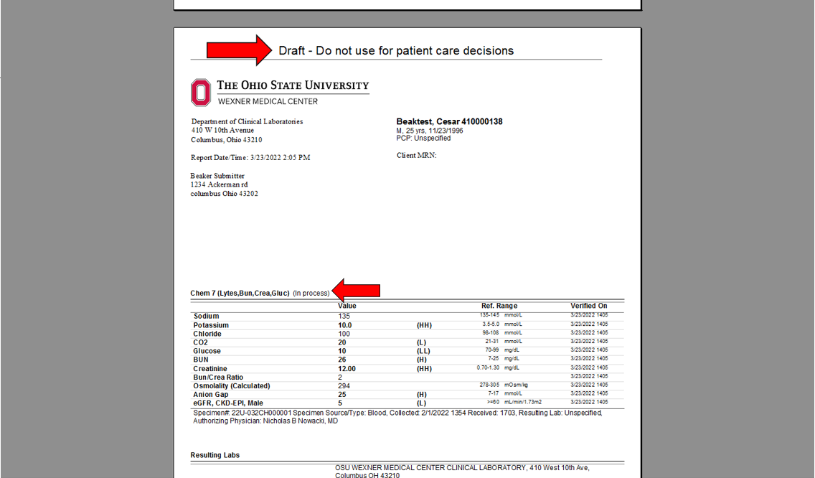

Courtesy Calls
  - Courtesy calls do NOT need to be called to RN or MD. Please call to an appropriate staff member.
  - Two attempts must be made (two different numbers / methods)
    - Document in the comm log attempts made or person contacted.
      - Two different methods include, not limiting to: directly calling clinic / floor / unit; paging physician; locating the office number use the directory on MyTools, calling hospital operator 3-8000; URL account / client database listing, or Google/web search. Refer to Section 10.

  - If two unsuccessful attempts are made, change to courtesy call “not available”
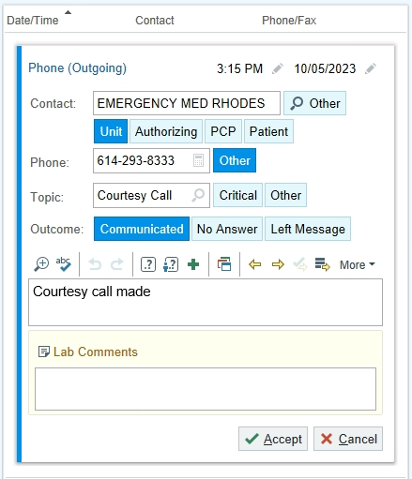

Tools to contacting ordering / attending physician:
  - NOTE: Applicable tools must be utilized before contacting the on-call pathologist.

  - To locate the office number, use the directory on MyTools, hospital operator 3-8000, URL account / client database listing, or Google/web search.

  - On MyTools

    - Search under “Find a Physician”


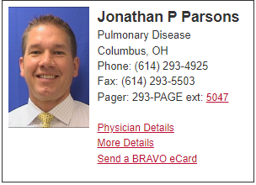
    - Click on “Physician Details” for office phone numbers.

  - Hospital operator 3-8000, (614)293.8000
    - Call the operator and ask who is on call for the ordering physician.
    - Page that person and follow the above process to communicate the critical result.
    - The hospital operator is often the easiest, and most efficient way to find an on-call physician to take results.

  - URL account / client database listing on L drive.

  - Google/web search for office number

  - Service On-call - Outpatients:
    - When appropriate and as a secondhand effort call the current on-call person for the service from which the patient was discharged by looking in IHIS.
    - In IHIS - Look in the right-hand side in the admission box under “discharge summaries” written in brown it has the service in
    - Look at current on call schedule, by service, in QGenda available on MyTools and the Pathology Internal Site.
        - QGenda - Home (sharepoint.com)

  - Attending, Ordering, “On Call” Physician, Or Other Person as Designated by The Client Cannot be reached following 2 attempts, 20 minutes apart:
    - During routine business hours (Monday through Friday 7:00am to 5:00pm): page the division director. They will assist with identifying an alternate physician for notification.
    - Review the patient identification, test result information, and attending/ordering physician information with the director.
      - If the division director is unable to identify a physician to accept the value, they should contact the Laboratories medical director or the Critical Event/Results Officer.
      - If the division director cannot be reached, page the Laboratories medical director.

    - After 5:00pm and on weekends/holidays:
      - Contact the CP pathology resident on-call.

      - Review the patient identification and test result information with the resident. Make sure you have the patient contact information including phone number available to provide to the resident.

      - The resident, in conjunction with the CP faculty pathologist on call, will determine if notification can wait until the next day, whether the Critical Event / Results Officer needs to be paged to assist in the management of the patient, or the patient needs to be contacted directly and advised to seek medical attention.
        - ONLY the resident / CP faculty pathologist on call will page the Critical Event/Results Officer if needed.
        - If the patient is to be contacted directly, the resident or the CP faculty pathologist will contact the patient.
          - Resident or faculty pathologist will provide the name of the person notified and the date and time of notification to the laboratory. Laboratory personnel must document the notification in the computer.
      - If notification of the critical value can wait until the next day, residents will provide their name to the laboratory personnel with instructions to proceed with attempts to contact the ordering provider during business hours.
- In the comm log add the smart phrase “.CRITPATH” to add the statement: “After repeated attempts to notify provider, called to Pathology resident on-call (xxx name to be added by MLS) concerning critical result. Critical result was reviewed and determined that attempts to notify the ordering provider can be resumed during business hours.”
- Add the resident’s first and last name.

RELATED DOCUMENTS
  - Refer to QPulse System or Document Detail Report for related Laboratory Policies, Procedures, and Master Forms
  - Medical Center Policy: Critical Tests and Results 03-40 (Hospital) v.4 (policytech.com)

Help Guide: To page the CP Pathology Resident on-call:
- Go to MyTools

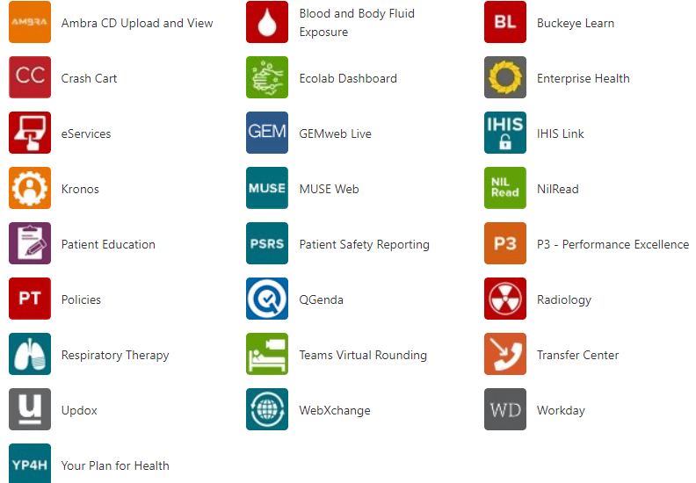
- Click the QGenda Icon Pathology Pager Number
  - QGenda - Home (sharepoint.com) for tips, training, and quick login.



- Type in the box to Contact Microbiology Regarding a critical value and include your nearest area phone number.

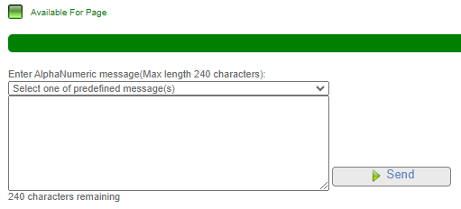
- Click Send

