Providing lab results requires everyone’s cooperation. The process of drawing blood is the most crucial step to obtaining accurate results. Thank you for all your hard work and dedication to providing the best care possible for our patients.

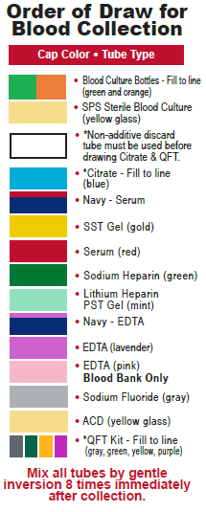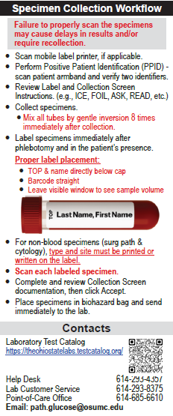
Preferred Venipuncture Sites
Use a 21 or 23 gauge needle whenever possible based on the patient’s vein to be accessed
- Median cubital vein
- Median cephalic vein
- Median basilic vein
(Use basilic vein only if no other vein is available)

QuantiFERON-TB Gold PLUS Collection Instructions

If a butterfly needle is used, first collect other required tubes or use a “purge” tube to remove the air. Then proceed with collecting the QFT 4-tubes.
DO NOT FILL TUBES WITH A SYRINGE.
- Tubes should be at 17-25°C (63-77°F) at the time of blood filling.
- Collect 1 ml of blood into each of the 4 tubes. Order of draw:
1. Gray (Nil) 2. Green (TB1 )
3. Yellow (TB2) 4. Purple (Mitogen)
    - Tubes fill slowly
    - Keep each tube on the needle for 2-3 seconds after
tube appears to have completed filling.
    - When tube is upright, blood level must be within the
small black mark on the label on all 4 tubes. Over filling
or under filling will cause the test to be rejected.
- Immediately invert the tubes 10 times, just firmly enough to ensure inner surface of tube is coated in blood (to solubilize antigens on tube walls). Do not vigorously shake them. Over-energetic shaking could lead to aberrant results.
- The tubes can be labeled with any of the 4 QFT test labels. Make sure the QuantiFERON band and entire specimen volume are visible.
- Write the collect time on ALL the tubes.
- Maintain the tubes at room temperature and transport in bag provided to CPA, S326 Rhodes Hall as soon as possible.

HOW DO THESE PROBLEMS AFFECT TEST RESULTS?

Hemolysis | May cause falsely decreased results for analytes such as direct bilirubin, RBC count, Hematocrit (HCT), and aPTT.  May cause falsely increased results for analytes such as potassium, ammonia, magnesium, phosphorus, AST, ALT, LDH and PT
Clotted | May cause falsely decreased platelet count (PLT) and hemoglobin (Hgb). PT and PTT may be falsely increased or decreased depending on clot size and composition.
IV Contamination | May affect many analytes due to dilution and contamination from IV fluids or medications. Examples include falsely decreased Hgb, PLT, and WBC count, falsely increased sodium (Na), chloride (Cl), and PT/PTT
EDTA Contamination in Chemistry specimens | May cause falsely increased K and falsely decreased calcium (Ca)
Delayed sample processing/recollection | Recollection delays result reporting and increases patient wait time for laboratory results
Prolonged tourniquet time | Hemoconcentration may cause falsely increased concentrations of protein-based analytes, packed cell volume, and cellular components. Tourniquet application should not exceed 1 minute before venipuncture.
Patient identification errors | May result in serious patient harm if clinical decisions or blood products are based on mislabeled specimens

HEMOLYZED SPECIMENS

Hemolysis occurs when red blood cells (RBCs) are disrupted, releasing hemoglobin into the plasma or serum. It is often identified after centrifugation, when the plasma or serum appears pink (mild hemolysis) to red (gross hemolysis).

Patient Conditions that May Cause Hemolysis  - Hemolytic anemia  - Liver disease  - Transfusion reactions  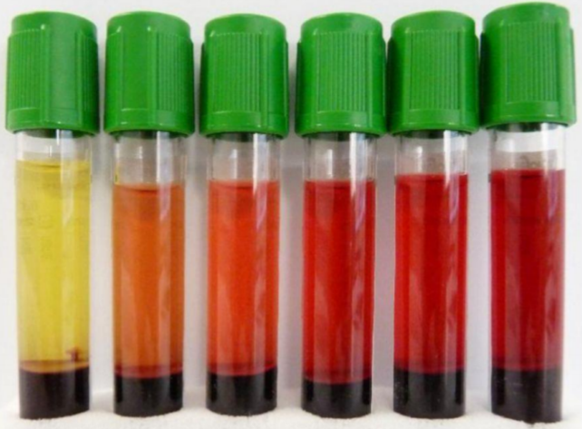 | Procedural Practices that May Cause Hemolysis  - Collecting blood at the time of IV placement  - Drawing specimens from a vascular access device (VAD)  - Using a needle with a bore too small for the vein  - Vigorous tube mixing or rough handling during transport  - Underfilled collection tubes  - Excessive force applied to the syringe plunger  - Maintain < 1 mL dead space  - Frothing of blood due to an improper needle-syringe fit.  - Forcing blood from a syringe into an evacuated tube  - Drawing blood from a vein with a hematoma  - Continuing sluggish draws due to collapsed veins or improper needle placement  - Excessive squeezing or “milking” of the puncture site during skin puncture collection

UNDERFILLED/OVERFILLED TUBES

- Most blood collection tubes contain additives designed to prevent clotting or stabilize analytes only when the correct volume of blood is collected.
- Each laboratory test also requires a minimum specimen volume to allow for accurate pipetting and potential follow-up testing.
- Underfilled or overfilled tubes may produce inaccurate laboratory results.
- Underfilling can lead to dilutional effects, while overfilling may result in clot formation due to insufficient anticoagulant.
- Blood culture bottles must be filled to the indicated fill line:
  - Adults: 8-10mL
  - Infants: ~1mL
- Light blue sodium citrate tubes used for coagulation testing must be filled exactly to the
fill line.
  - These tubes require a precise 9:1 ratio of blood to anticoagulant.
  - Any deviation from this ratio (underfilling or overfilling, including filling to the
cap) may result in erroneous coagulation results.
- A discard tube should be drawn before collecting a sodium citrate tube:
- This minimizes contamination with tissue thromboplastin released during venipuncture.
  - When using a butterfly set, the discard tube also removes air from the tubing to
ensure proper fill of the citrate tube.

ASEPTIC TECHNIQUE

- Perform hand hygiene
- Clean with 70% alcohol or >0.5% Chlorhexidine Gluconate sponge prep (Chloraprep) with back and forth motion
- Use needles one time only

CLOTTED SPECIMENS

Inadequate mixing of blood collection tubes is a common cause of clot formation.

To prevent clotting, gently invert the tube at least 3 times immediately after it is filled, then continue gentle inversions to a total of 8-10 inversions to ensure complete mixing with the additive.

For line draws collected into a syringe,
the specimen should be transferred
promptly into the appropriate
Vacutainer® tube by piercing the
stopper, followed by gentle inversion
of the tube to ensure proper mixing and
prevent clot formation.

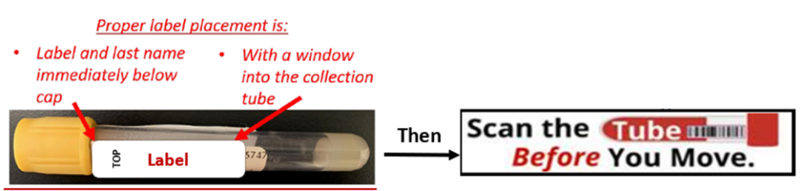
IV CONTAMINATION

- Draw sample from the opposite arm when possible.
- Stop infusion for two minutes prior to obtaining the sample.
- Refer to the Therapeutic blood draws section of the Infusion Therapy Managment (Nursing) policy for details.

IMPROPERLY COLLECTED OR PATIENT ID ERRORS

Correct identification of patient specimens using 2 patient identifiers is essential for reporting accurate laboratory results. Proper specimen labeling, scanning and documentation at the time of collection are critical for safe, accurate, and timely test completion.

Please follow the procedures outlined in the IHIS specimen collection tip sheets with the following key takeaways:

- Always Scan Before Moving on to complete collection documentation, including selecting [Accept]
- Always document the specimen source for all non-blood specimens, including the specimen type and exact collection site

A variety of blood collection tubes and urine preservatives are used to maintain specimen stability until laboratory testing can be performed. Refer to the Lab Testing Menu or the laboratory test label to confirm acceptable tube types and collection requirements.

For more comprehensive information, refer to the

Standards for Acceptable Clinical and Anatomic Pathology Specimen Collection policy,

Infusion Therapy Management (Nursing) policy, and

Blood Cultures (Nursing) policy.

________________
THANK YOU

