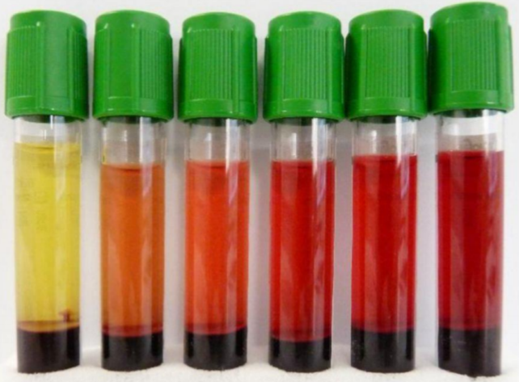
What is hemolysis?
- Hemolysis occurs when red blood cells (RBCs) break apart and hemoglobin and intracellular components are released into the plasma/serum.
- Hemolysis may occur intravascularly due to various disorders/diseases/drugs (~2% of hemolyzed specimens); or during blood collection and/or transport (~98% of hemolyzed specimens).

Why do we care about hemolyzed specimens?
- Certain lab tests can be affected and the reported results will be unreliable.
- It may cause falsely decreased results for tests such as direct bilirubin, RBCs, HCT, and aPTT.
- It may cause falsely elevated results for tests such as potassium, ammonia, magnesium, phosphorus, AST, ALT, LDH and PT
Evidence-based strategies to minimize hemolysis caused during blood collection
- Avoid collecting blood when starting an IV
- Consider using venipuncture rather than a vascular access device (VAD)
- Choose the needle size that best correlates with vein size
- Gently invert tubes 8-10 times to mix; NEVER shake tubes
- Fill tubes fully as excess anticoagulants is hard on fragile RBCs
- ≤ 1 minute tourniquet time
- Use vacuum tube rather than syringe
  - If a syringe must be used, keep < 1 mL of dead space and allow the tubes to fill slowly
- Stop and correct if the blood flow is slow or frothing
- Consider drawing in a serum separator tube (gold top) if previous attempt with lithium heparin separator tube (mint green top) is unsuccessful
  - Gold top must also be an acceptable tube type for the test requested
- Consider walking a specimen down to the laboratory to avoid stress caused by transport via pneumatic tube system
Choosing a needle gauge
- Using a needle size too large can tear the vein and cause a hematoma
- Using a needle size too small can damage blood cells
- Needle sizes should be chosen according to the vein size
- 25 gauge should be rarely used
Needle Gauge | Adult | Pediatric/elderly/ small veins | Neonate | Butterfly Color
21 | Yes |  |  | Dark Green
22 | Yes | Yes |  | Black
23 | Yes | Yes | Yes | Light Blue
25 | Rarely needed | Rarely needed | Yes | Dark Blue

References
- WHO guidelines on drawing blood: best practices in phlebotomy. 2010.
- Heyer N, et al. Effectiveness of practices to reduce blood sample hemolysis in EDs: a laboratory medicine best practices systematic review and meta-analysis. Clin Biochem. 2012 Sep;45(13-14):1012-32.
- Lowe G, et al. Nursing blood specimen collection techniques and hemolysis rates in an emergency department: analysis of venipuncture versus intravenous catheter collection techniques.
- Mullins G, et al. Smartphone monitoring of pneumatic tube system-induced sample hemolysis. Clin Chim Acta. 2016 Nov 1;462:1-5.

